Before you begin, decide with your group:

* Name of the new hire ----- Pil So
* Non-technical role at StackFull Software (i.e., recruiter, sales associate, social media associate) ----- Recruiter
* Department they work in (i.e., HR, Sales, Marketing) ---- HR

Step 1

Join the computer to the domain (the domain name is contoso.com). The username/password is administrator/Pa$$w0rd.

Make sure you change the ip address to 172.31.48.240 for the ipv4 address in your driver settings.

Got to control panel and then to Network and Internet.

Network and Sharing Center

Change Adapter Settings

Right click on Ethernet 2 and go to properties

And then go to Internet Protocol Version 4

Double click on the yellow and then go to DNS server address.

Hit Ok on all and then go to the next steps.

Bottom Left type here to search for “this pc” and right click properties and go to rename this pc (advanced) and then go to change.

Then put in the username and password, which is administrator/Pa$$w0rd

You are now welcomed into the domain.

You can either to 23 things you can either restart it or use CMD: gpupdate /force

In order to accept the policy within Active Directory Or AD for short.

You can also verify when you look at the internet icon to see if your in the domain.

Step 2

Switch to the server. Create a user for the new hire and set a password.

Use the search box or hit the magnifying glass to search for active directory or use the pin to get to active directory.

Right click on the contoso.com domain and then go to new and then user.

Then create a password and it’s up to you to decide what password and make sure you check on next login, so the user can set up their own but for this exercise I will uncheck mine.

Verify that it’s in your domain.

Step 3

Create a group with the department name and place the user in that group.

Right click on the domain and go to new and then go to group.

There you will need to put in whatever department the user is in.

And then go to right click on find and then find your user and right click on the name and then go to properties.

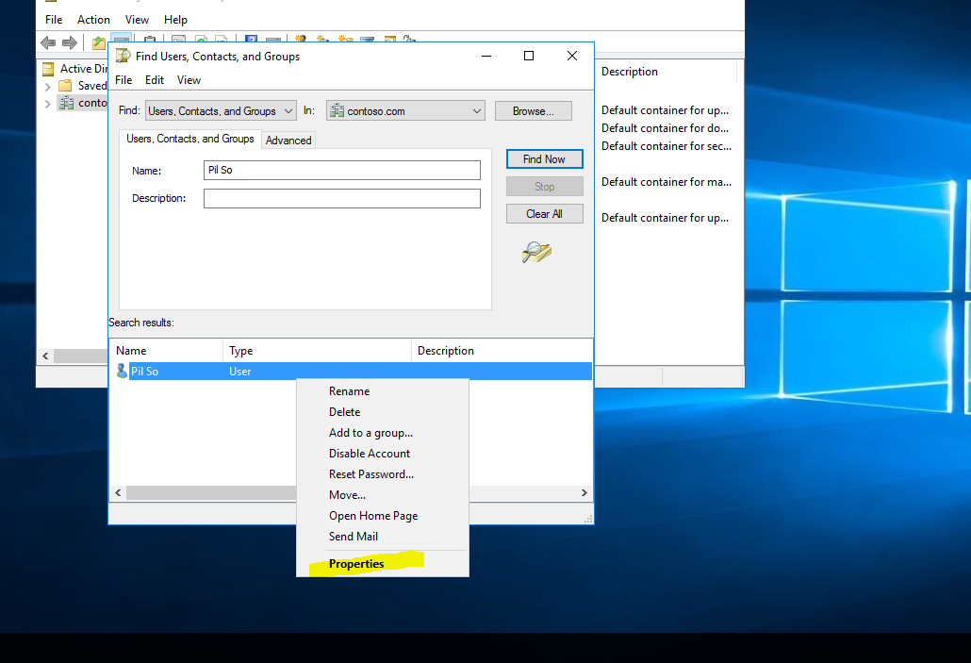

Then go to member of tab and then press the add button and then add whatever department he or she is in.

Step 4

Create a share on the server with the department name and share it only with people who belong to that department (read and write permissions). In the folder, create a text document called test.txt.

There are several ways to do this, but this is how I do it.

Create a folder within the desktop or wherever you like to put the shared folder in.

And then create the documents you want to go back to HR folder and then right click properties.

Go to the sharing tab and then hit share, after which put in a name and then add you can also change permissions when you look at the yellow.

Go back to Desktop 2 and then you can map the network folder into your drive.

Depending on if you know the Network Path.

\\EC2AMAZ-L3OOUG8\Users\fstack\Desktop\HR

Go back to Desktop 2 and then add the network drive into your c drive.

Right click anywhere is a blank space in the devices and drive and go to add a network location.

Hit next and then put the network path on your network drive.

Hit next and you should see it in network location.

Step 5

Create an OU with the department's name and place the user, group, and computer in the OU. Attach a GPO to the OU you created.

Go back to server and then right click on the domain. And go to new and then go to organizational unit.

Then create your name and hit ok

Right click on your user and then go to move and move it to the Organizational Unit. Same as follows for the security group.

Step 6

Edit the GPO and apply the following rules:

* A message should appear whenever the computer starts (do not install unauthorized programs).
* Prevent the user's access to CMD.
* Add script to the user's login to map the share you created.
* Disable the run command from the start menu.

A message should appear whenever the computer starts (do not install unauthorized programs).

Search for Group Policy Management and then click on Default Domain Policy and right click it and then go to edit.

A message should appear whenever the computer starts (do not install unauthorized programs).

In the left pane of the Group Policy Management Editor, navigate to Computer Configuration> Policies > Windows Settings > Security Settings > Local Policies and select Security Options. On the right pane of the console, select the Interactive Logon: Message text for users attempting to logon policy.

After which check define this policy and then write the message you want to put in and then hit apply.

Also which go to interactive logon: Message title for user and double click on that and create a title for this message.

Prevent the user's access to CMD.

In the Group Policy Management Editor by right clicking default domain policy and then go to edit, navigate to User Configuration/Administrative Templates/System. Look for the policy setting “Prevent access to the command prompt” and select Edit.

After which you Enabled it and hit apply and Ok.

Add script to the user's login to map the share you created.

Go to group policy management and then go to HR and right click to get to create a GPO in this domain.

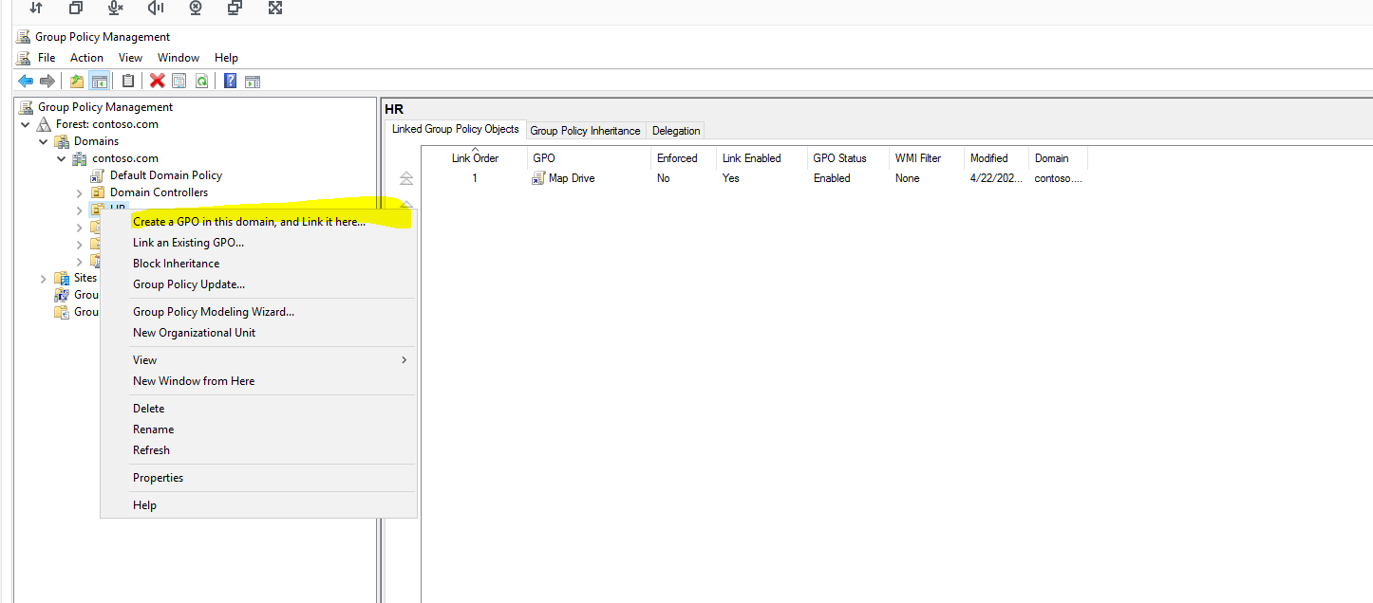

Name the GPO to however you want it to be.

And then hit ok. After which right click the map drive and go to edit.

After which you go to User configuration --- preferences --- windows settings –then to drive map.

Double click on Drive Maps and then right click new and the map drive. Put the path you want in the location and make sure you label it as and put a map letter on it as well. And use create as the action.

Disable the run command from the start menu.

First you need to create another GPO within HR and make the policy Disable Run Command. After which you need to right click Disable Run Command and go to edit.

Open Group Policy Editor and navigate to User Configuration > Administrative Templates > Start Menu and Taskbar. Double-click on Remove Run menu from Start Menu. Then go to hit Enabled and hit ok.

Once everything is done go to CMD right click make sure you’re using administrative credentials after which. “gpupdate /force” to make sure that desktop2 can catch the policies.

Step 7

Check the Event Viewer on the server machine and write down the last successful login from your user. (Note: You must log in with the domain administrator account).

administrator/Pa$$w0rd.

Sign out and then use the administrator account in red, and then go search using the magnifying glass event viewer.

After which Windows Logs---- Security----

Check the logs make sure your in Logon in Task Category

NullSID security ID – time stamp: 4/22/2024 time: 8:46.

Step 8

Use PowerShell to check what the latest program installed on the computer was.

Press the Windows Key + X and select Windows PowerShell (Admin).

Type in “wmic qfe list”.

This will tell you all the updates and programs installed on the computer was.

Step 9

Write a PowerShell script that gives a list of all running services and puts it in a file named running_services.txt.

Go to PowerShell and make sure you’re an administrator.

After which copy the code and run it, it should execute a text file in your c drive.

Get-Service | where {$_.Status -eq "Running"} | Out-File "C:\running_services.txt"

